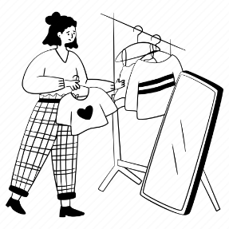
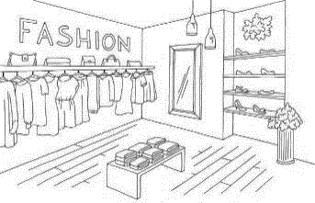
Shopping: Dialogue
Clerk
Customer
Hello. May I help you?
Yes, please.
I’m looking for a sweater.
(I’m looking for a pair of ______.)
How about this one?
(How about these ones?)
That looks nice, but it’s too small.
(They look nice, but they’re too small.)
Yes, please.
Shall I show you a bigger one?
(Shall I show you bigger ones?)
This is a medium.
(These are a medium.)
Can I try this (them) on?
Sure.
It looks nice on you.
(They look nice on you.)
OK. Thank you.
How much is it?
(How much are they?)
I’ll take it (them).
It’s (They’re) fifty dollars.

A
B

C

D

E

Toolbox:
A | B | C | D | E
shirt, dress, suit, hoodie, tie, T-shirt, cap, watch, hat, backpack, jacket, scarf | shoes, boots, gloves, shorts, sandals, glasses, socks, slippers, pants, sneakers | smaller  longer  shorter | small  large  extra large | 25  40  100  250

