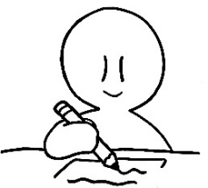
Write the correct word!

1. Your _________ is very stylish. ( hat / hot )
2. My favorite _______ is pistachio. ( nut / hut )
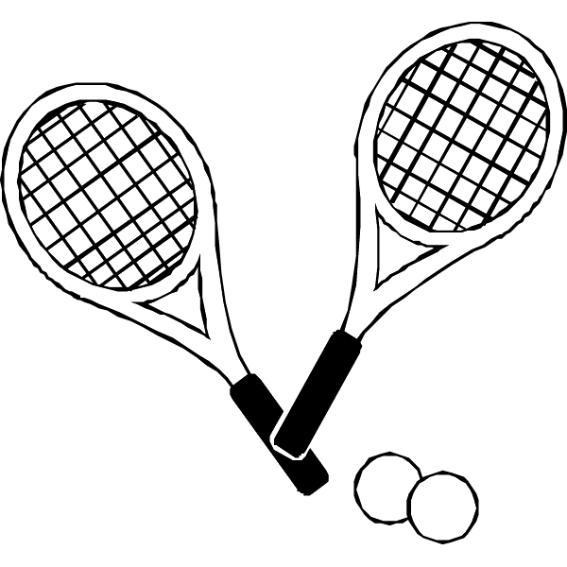
3. I’m in the tennis ____________. ( club / dub )
4. Do you ________ any money? ( hare / have )
5. My favorite season is ___________. ( fall / full )
6. My birthday is ________ 5th. ( May / Max )
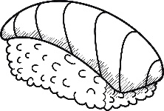
7. January is the first ____________. ( month / mouth)
8. Sashimi is delicious with _____ sauce. ( soy / say )
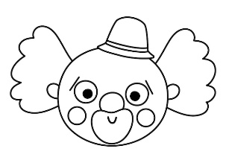
9. Please _________ me the answer. ( snow / show )
10. He is walking _______ the stairs. ( clown / down )
11. She takes __________ of her son. ( care / cave )
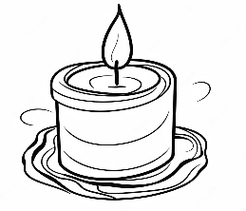
12. Learning English is __________. ( fan / fun )
13. Candles are made from ________. ( wax / way )
14. Close your ________ when eating. ( month / mouth )
Score: / 14

