At a Restaurant
- What is your favorite appetizer (前菜)?
______________________________________________________________________

- What is your favorite dish (昼・夜ごはんの食べ物)?
______________________________________________________________________

- What is your favorite drink?
______________________________________________________________________

- What is your favorite dessert (デザート)?
______________________________________________________________________
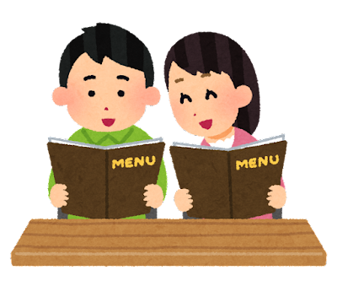
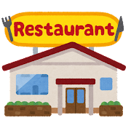
Script #1
Server (給仕) | Customer (顧客)
1. Hello, welcome to _______________ how may I help you?  3. Okay, any drinks?  5. And would you like a dessert?  7. So, that is ________ (顧客のA), ________ (顧客のB), ________ (顧客のC), and ________ (顧客のD)? | 2. I would like the ________ (A) and ________ (B) please.  4. Yes, a ________ (C) please.  6. Yes, I want the ________ (D) please.  8. Yes, thank you.

Script #2
Server (給仕) | Customer (顧客)
1. Welcome to _______________. What would you like?  3. Okay, what would you like to drink?  5. Perfect, and how about a dessert?  7. So, you would like ________ (顧客のA), ________ (顧客のB), ________ (顧客のC), and ________ (顧客のD)? | 2. Can I get the ________ (A) and ________ (B) please?  4. A ________ (C) please.  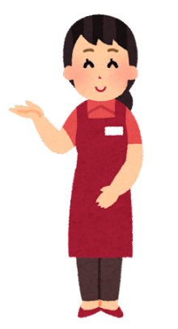  6. Yes, I’d like the ________ (D) please.  8. Yes, thank you.

Note Sheet
ノートシート

(A前菜, Bごはんの食べ物, C飲み物, Dデザート)
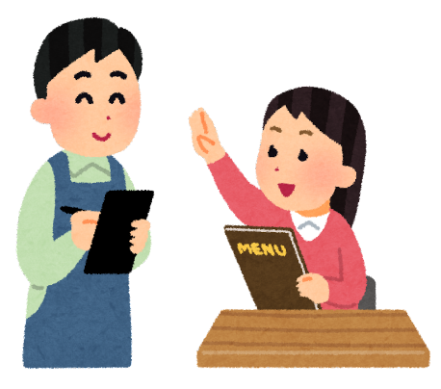
Customer (顧客) #1  A  B  C  D | Customer (顧客) #2  A  B  C  D
Customer (顧客) #3  A  B  C  D | Customer (顧客) #4  A  B  C  D
Customer (顧客) #5  A  B  C  D | Customer (顧客) #6  A  B  C  D
Customer (顧客) #7  A  B  C  D | Customer (顧客) #8  A  B  C  D

