Name: _____________ Class: _____ Number: ____ Date: ___/___
FILL THE TOWN RACE
park  school  library | shop  restaurant  supermarket | hotel  hospital  post office
‘There is a shop next to the bank.’ ‘There is a shop across from the bank.’
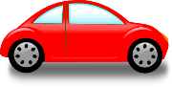
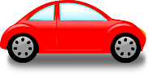

bank

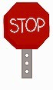

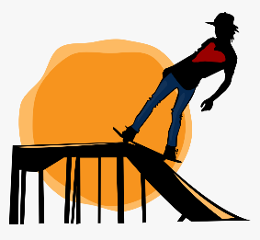
MY TOWN
There is a skate park near the river. It has some ramps.
You can see many skateboarders there.
- _________________________________________________________
_________________________________________________________
_________________________________________________________
- _________________________________________________________
_________________________________________________________
_________________________________________________________
- _________________________________________________________
_________________________________________________________
_________________________________________________________

