Name: Date:
Connect lines and write the sick name
Medicine Name Sick Name
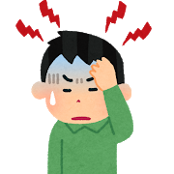
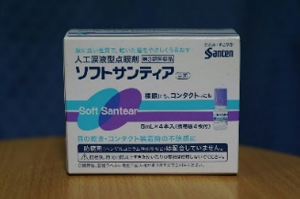
eye drops
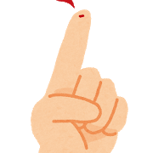
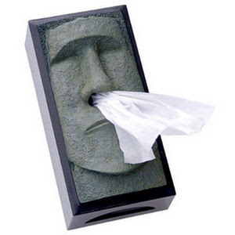

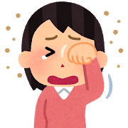
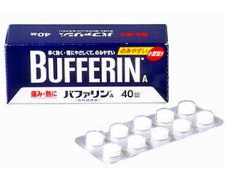
dry eyes

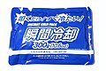
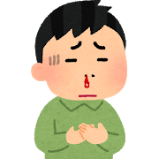

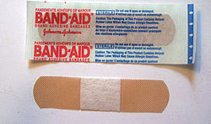
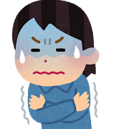

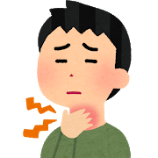

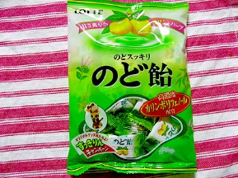
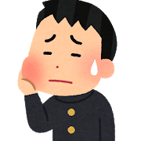

Sick names:
Dry eyes, Sore Throat, Toothache, Bloody nose, Finger cut, Headache, Cold
Medicine names:
Eye drops, Cough drop, Blanket, Bandaid, Ice pack, Tissues, Bufferin

Activity number 2

Pick one medicine name and one sick name.

MEDICINE ___________________ SICK______________

You are sick. You need help. Find help. Ask your classmates for help.
Pick 1 illness and 1 medicine from above.

How to play:
- Play rock, paper, scissors. Winner is A
A: Excuse me, I have a ________ (sick name)
B: Ok here you are.

Find your correct medicine.
Write down the name of the student in the good medicine.
Write down the name of the medicine in the bad medicine.
If you get 3 bad medicine you die.
If you get 3 good medicine please come to the teacher and get a sticker.

GOOD Medicine | BAD Medicine

