Find the hidden letters to make a Halloween word
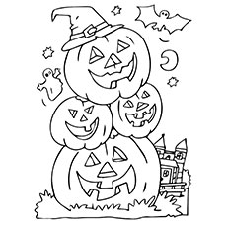
G
H
O
S
T

Name: ______________________ Class/No: _________

Find the hidden letters to make a Halloween word
G
H
O
S
T

Name: ______________________ Class/No: _________

Find the hidden letters to make a Halloween word
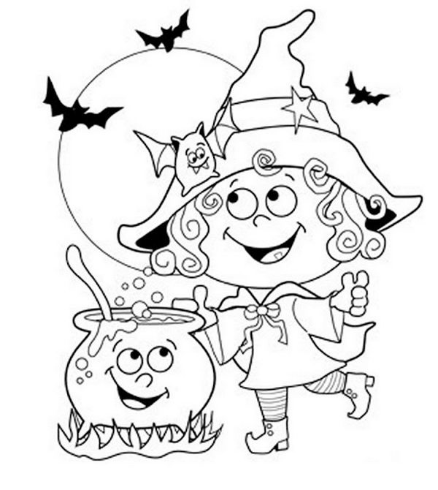
A
B
T

Name: ______________________ Class/No: _________

Find the hidden letters to make a Halloween word
A
B
T

Name: ______________________ Class/No: _________

