CLUE: A Mystery Solving Game

There was a robbery in (your city or town)! We have to help the police solve it! Use the clues to answer these questions: Who did it? Where did the crime happen? What was stolen?

Use this table to help you solve the crime.

Suspect | Location | Valuable Item
Your tip for the police: If I were you, I would talk to (investigate) the (suspect). I saw them at (location) with a (valuable item).
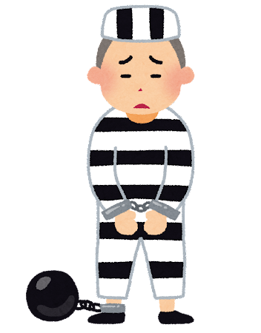
Mystery Solved!
Who?______________________
Where?____________________
What?_____________________

