Taxi driver
- Hello/Good morning/Good Afternoon.
- Where would you like to go?
- Shall I take you there now/Shall we go?
- Would you like me to…?
- …Help with your bags.
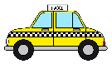
- …Roll down the windows.
- I would like to go to…
- Yes, please.
- No, thank you.
- No problem!
Starbucks Barista
- Hello/Good Morning/Good Afternoon.
- What can I get for you today?
- Would you like anything else?
- Will that be all?
- Can I have your name please?
- Could I have a/an…?
- Espresso/Latte/Cappuccino/Frappuccino.
- Sure!
- Yes, that will be all.
- No, thank you.
- No problem!
McDonald’s Drive thru
- Hello/Good Morning/Good Afternoon.
- What can I get for you today?
- Would you like me to…?
- Will that be all?
- Could you go to the next window please?
- Could I have a/an…?
- Big mac/Happy meal/Samurai Mac.
- French Fries/chicken nuggets.
- Large/Medium/Small Soda.
- Yes, please.
- I’m sorry, we don’t have that.
- No, thank you.
- Sure!
Helping a lost foreigner
- Hello/Good Morning/Good Afternoon.
- Are you lost?
- Do you need help?
- Where would you like to go?
- Would you like me to show you…/tell you where…/call someone?
- Could you tell me/help me/show me where?
- …Help with your bags.
- Yes, please.
- No, thank you.
- I don’t know where that is.
- No problem!

Hotel Receptionist
- Hello/Good Morning/Good Afternoon.
- Can I help you?
- Would you like to check in?
- Could I have your Name/ID/passport please?
- Do you need help with anything else?
- Would you like me to…?
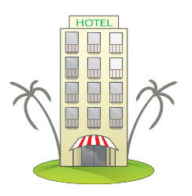
- …Send your bags to your room?
- …Send room service?
- Yes, please.
- No, thank you.
- Sure! No problem.
- Enjoy your stay!
Waiter at a Restaurant
- Hello/Good Morning/Good afternoon.
- What can I get for you today?
- Would you like to hear our specials?
- Would you like me to bring a bottle of wine?
- Will that be all?
- Could I have the check please?
- I would like a/an…
- Steak/Chicken teriyaki/hamburger.
- Enjoy your meal!
- Yes, please.
- No, thank you.
Retail Store Worker
- Hello/Good Morning/Good Afternoon.
- Is there anything I can do for you today?
- Will that be all?
- Would you like to try…?
- Shall I show you…?
- Could you tell me…/show me…?
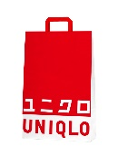
- …where the dressing room is.
- …Where men’s shirts are.
- …Where women’s dresses are.
- Yes, please.
- No, thank you.
- Sure! No problem.
Lost in the airport
- Hello/Good Morning/Good Afternoon.
- Are you lost?
- Do you need help?
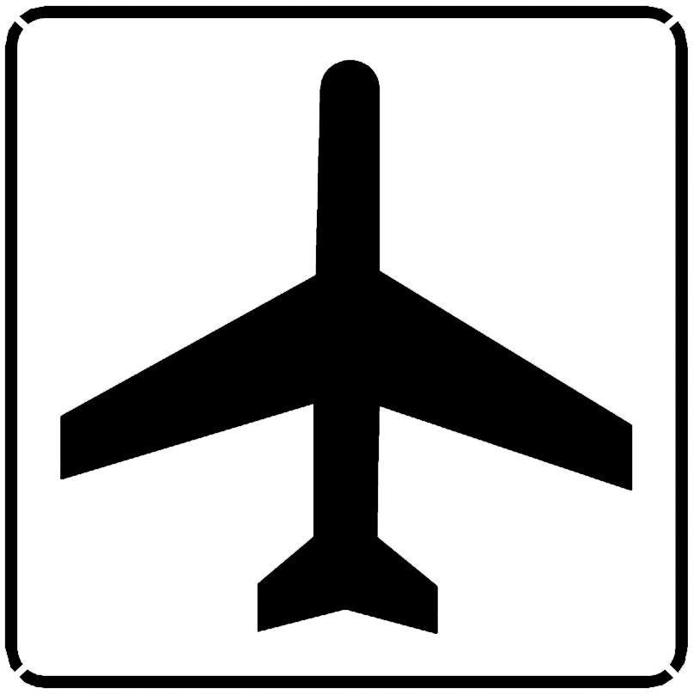
- Would you like me to…?
- …Call security?
- …Show you your gate?
- …Help with your bags?
- Could you tell me where…?
- …Gate D4 is?
- Yes, please
- No, thank you.

Please write a script about your scenario. Use the key phrases on the previous page as references. Please feel free to use any vocabulary you like. Afterwards, perform a roleplay with your partner.
あなたのシナリオについてスクリプトを書いてください。前ページのキーフレーズを参考にしてください。お好きな語彙をご自由にお使いください。その後、パートナーとロールプレイを行ってください。

