Let’s think outside the box!

Complete the picture below. It’s not a heart. It’s a …

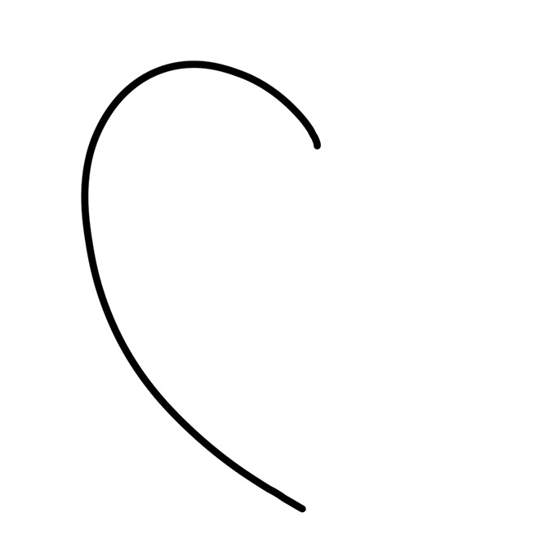

Let’s think outside the box!

Complete the picture below. It’s not a heart. It’s a …

