Name: ______________________________________ Class: ___ Number: ___
Do you like playing the piano ?
Yes, I do. / Yes, I do, a little. / No, I don’t.
1. BINGO! Get 2 bingos.
playing basketball

sign:

sign: __________________
taking picture s

sign: sign:

sign: __________________
reading books

sign:

sign: __________________

watching TV

sign:
drawing pictures

sign:

sign: __________________
going shopping

sign: __
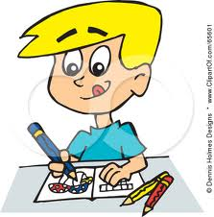

singing karaoke

sign:
eating natto

sign:
studying English

sign:
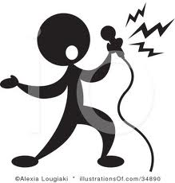

2. Write sentences about your friends. example: Ms. Onna likes watching TV .

1) ____________________________________________________________________________

2) ____________________________________________________________________________

3) ____________________________________________________________________________

4) ____________________________________________________________________________

5) ____________________________________________________________________________

3. Word Find:
dancing drawing pictures eating natto
going shopping playing basketball reading books
recycling reducing reusing
running singing karaoke taking pictures
watching TV

