Name: ___________ Class: ____ Number: ___ Date: ___/____
DARUMA
QUIZ
- ________________________________________
- ________________________________________
- ________________________________________
- ________________________________________
- ________________________________________
- ________________________________________
- ________________________________________
- ________________________________________
- ________________________________________
- ________________________________________
- ________________________________________
- ________________________________________
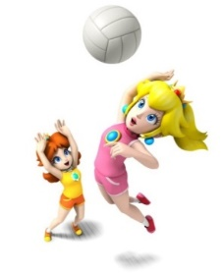
NOW or EVERY WEEK
- What are Peach and Daisy doing now?
______________________________________________
木
- What does Mickey do on Thursday?
______________________________________________
- What is Kitty doing now?
______________________________________________
- What does Vader do every morning?
朝
______________________________________________
- What is Snoopy doing now?
______________________________________________
月
- What does Harry do on Mondays?
______________________________________________
- What is Minnie doing now?
______________________________________________
昼間っ
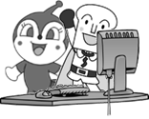
- What do Dokinchan and Shokupanman do every afternoon?
______________________________________________
- What are Yoshi and Kinopio doing now?
______________________________________________
毎日
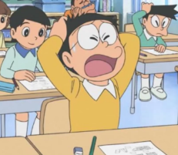
- What does Nobita do every day?
______________________________________________
- What are you doing now?
______________________________________________
- What do you do every weekend? 週末
______________________________________________
- What do you do every morning?
______________________________________________

