Name:____________________ class: ____ number: ___

○○ makes me ○○

Write about these pictures:

1.

2.

3.

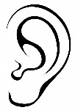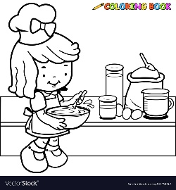





1. ______________________________________________________________
2. ______________________________________________________________
3. ______________________________________________________________

Write 3 original sentences:

1. ______________________________________________________________
2. ______________________________________________________________
3. ______________________________________________________________