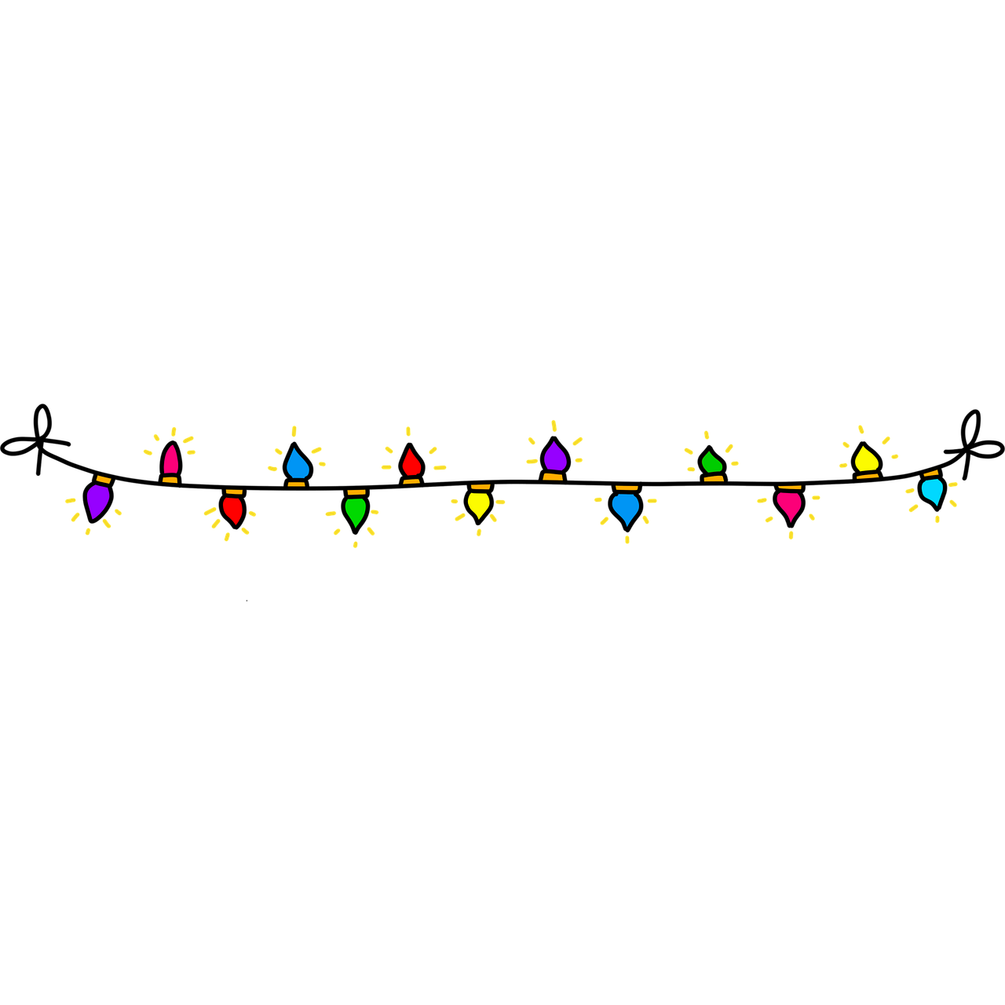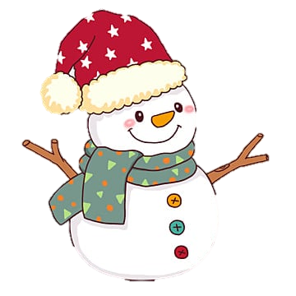Create your Snowman

|  |  |  |  |  |  |  |
| --- | --- | --- | --- | --- | --- | --- |
|  |  |  |  |  |  |  |
| **Body shape**  体の形 | Circle | Triangle | Square | Rectangle | Heart | Diamond |
| **Body parts**  体の数 | 1 | 2 | 3 | 1 | 2 | 3 |
| **Face**  顔 | Happy  😊 | Sad  ☹️ | Angry  😠 | Surprise  😮 | Silly  🤪 | Sleepy  😴 |
| Nose  鼻 | Carrot  🥕 | Eggplant  🍆 | Daikon  Vegetable Daikon Food Napa cabbage, vegetable, food, napa Cabbage, radish  png | Klipartz | Cucumber  🥒 | Broccoli  🥦 | Banana  🍌 |
| Buttons | 1 | 2 | 3 | 4 | 5 | 6 |
| Scarf Pattern  スカーフの模様 | Stripes | Zigzag transparent background PNG cliparts free download | HiClipartZigzag transparent background PNG cliparts free download | HiClipartZigzags | Dots | Simple Swirl Vector Art, Icons, and Graphics for Free DownloadSwirls | Christmas trees  🎄 | Stars  ⭐ |
| Hat  帽子 | Beenie | Cap Clipart Images | Free Download | PNG Transparent Background - PngtreeBaseball | Top hat Monopoly , Hat transparent background PNG clipart | HiClipartTop Hat | Cowboy  Cartoon Cowboy Hat Vector Illustration Stock Illustration - Download Image  Now - Cowboy Hat, Hat, Cowboy - iStock | Beret  5,000+ French Beret Stock Illustrations, Royalty-Free Vector Graphics & Clip  Art - iStock | French man, French bread, French culture | Brown rice hat, Vietnam Asian conical hat Sombrero Straw hat, Hat, angle,  hat, top Hat png | PNGWingRice Hat |
| Hands  手 | Sticks  Stick - Official The Forest Wiki | Mop Handle Vileda O-Cedar Cleaning, string transparent background PNG  clipart | HiClipartMop | Broom PNG, Broom Transparent Background - FreeIconsPNGBroom | Bat  Baseball Bat PNG, Vector, PSD, and Clipart With Transparent Background for  Free Download | Pngtree | Candy Cane Images | Free Photos, PNG Stickers, Wallpapers & Backgrounds -  rawpixelCandy cane | Pencil  Pencil PNG, Pencil Transparent Background - FreeIconsPNG |
| Color  色 | Red | Green | Light Blue | Yellow | Pink | Gray |