Class: No.: Name:
Date:
Unit 5-1: 関係代名詞which（目的語）
Goal: Let’s share what you think about

to try to give Taro
to eat right now to attend in high school
to visit someday to do right now
to buy right now to get from Kyoto
to be in the future to see at the cinemas

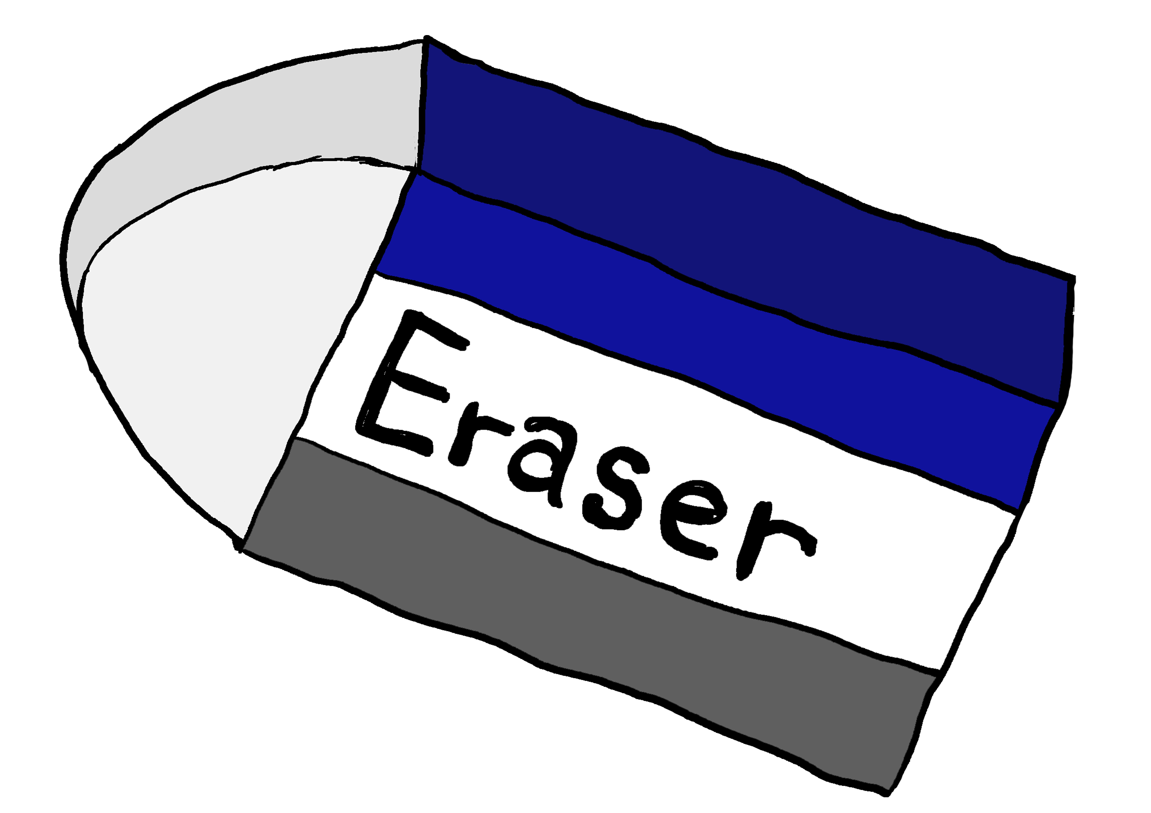

Examples
Italy is the country (which) I want to visit someday.
Sleeping is the only thing (which) I want to do right now.
Vet is the dream (which) I want to be in the future.
A new eraser is the item (which) I need to buy right now.
An iPhone 14 Pro is the present (which) I want to get from my father.

Choose 5 in the box and write sentences.

1.
2.
3.
4.
5.

