What & How

What do you have for breakfast?  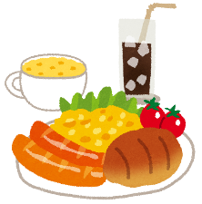  You: __________________  Friend: __________________ | What time do you go to bed?  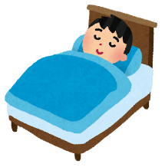  You: __________________  Friend: __________________ | How do you come to school?  You: __________________  Friend: __________________
What do you do on Saturdays?  You: __________________  Friend: __________________ | 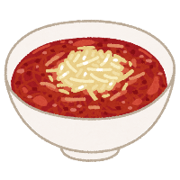  What food do you like?  You: __________________  Friend: __________________ | How are you?  You: __________________  Friend: __________________
What do you have on Mondays?  You: __________________  Friend: __________________ | What is your favorite day?  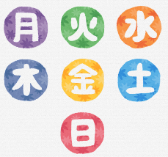  You: __________________  Friend: __________________ | What game do you like?  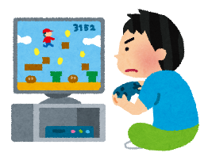  You: __________________  Friend: __________________
What do you eat for dinner?  You: __________________  Friend: __________________ | What do you want to be?  You: __________________  Friend: __________________ | How old are you?  You: __________________  Friend: __________________

