Changing Trains!
Look at the picture below. It shows the Kosei, Hokuriku, Biwako, and Kusatsu train lines of Shiga.
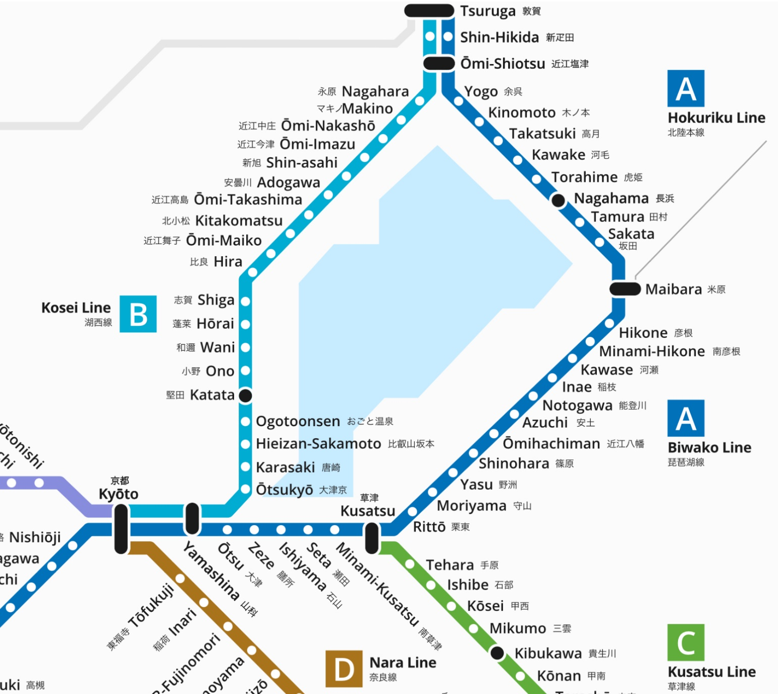

You are at Makino Station.
A: Could you tell me how to get to Kusatsu Station?
B: Take the Kosei Line.

Put the sentences in the correct order. 文章を正しい順序で並べなさい。
1. ( you / how / to / could / tell / get / me / to ) Makino Station?
____________________________________________________________________________
2. ( stops / how / here / is / from / ? / many / Inae Station )
____________________________________________________________________________
3. ( take / to / long / ? / how / to / Tsuruga / it / does / get )
____________________________________________________________________________
4. ( should / . / the / you / take / Biwako Line )
____________________________________________________________________________
Use the train line route to complete the dialogue.
You: Excuse me. Could you tell me how to get to ____________________________
Station?
Man: Sure. Take the _______________________ Line to ________________________
_________________________, and change trains there.
You: I see. Which line should I take from _____________________________
_________________________?
Man: Take the ______________________ Line. ____________________________ is
____________ stop(s) from ____________________________ Station.
You: Thank you very much.
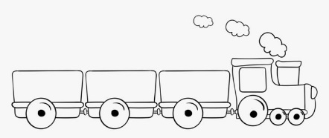
Man: My pleasure.

