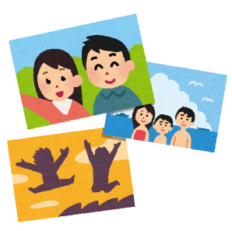
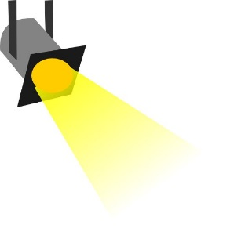
My highlights!

Me too!
Elementary school
First year
Second year
Third year

What were your friends’ highlights?

- _________________________________________________________
- _________________________________________________________
- _________________________________________________________
- _________________________________________________________
- _________________________________________________________

