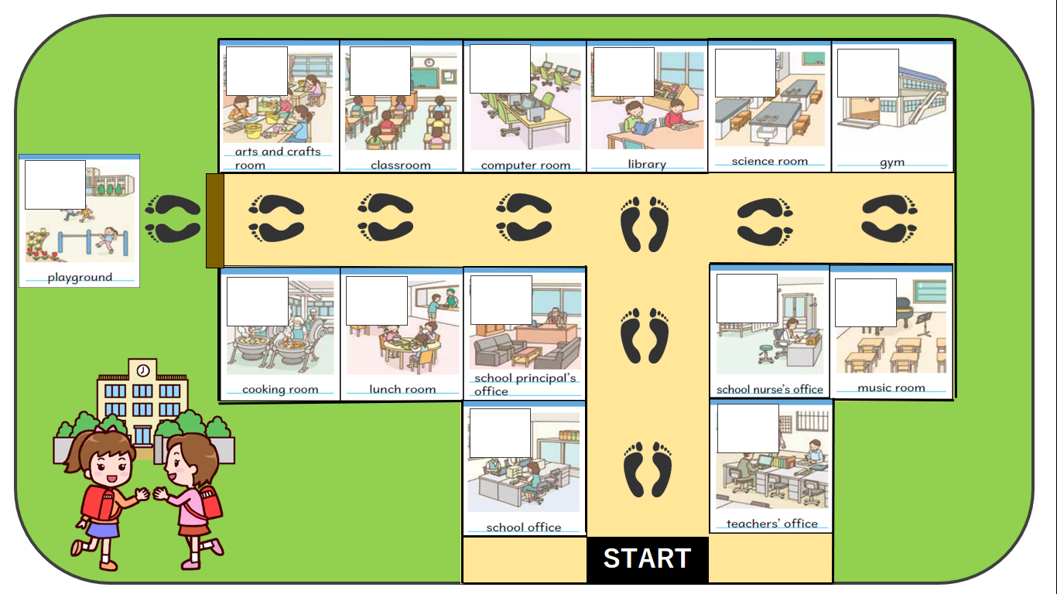**NAME: ______________________**