2 Truths and a Lie
真実ふたつと嘘ひとつ
Think. Write 2○（真実） and 1×（嘘）.
 | (ALT)の例 | - / ×
1 | I ate pasta yesterday.
2 | I was a soccer player in high school.
3 | I watched TV yesterday.
Write 3 sentences about you (2○ and 1×).
1
2
3
▫ yesterday(昨日) ▫ last night(昨夜)
▫ last week(先週)
▫ last month（先月）
▫ last year(去年)
▫ in elementary school
(小学生の時)

ときを表す語

▫ happy/ sad/ angry
▫ in the (art) club
▫ a fan of (BTS)

I was ( ).

▫ play played
▫ like liked
▫ study studied
▫ have had
▫ read read

I ( ).

Play in a group.
A: I was a soccer player in elementary school.
B: Were you a soccer player in elementary school?
A: Yes, I was. (○)/ No, I wasn’t. (×)

A: I ate pasta yesterday.
B: Did you eat pasta yesterday?
A: Yes, I did. (○)/ No, I didn’t. (×)
名前：
名前：
名前：

- / ×
1
2
3

- / ×
1
2
3

- / ×
1
2
3

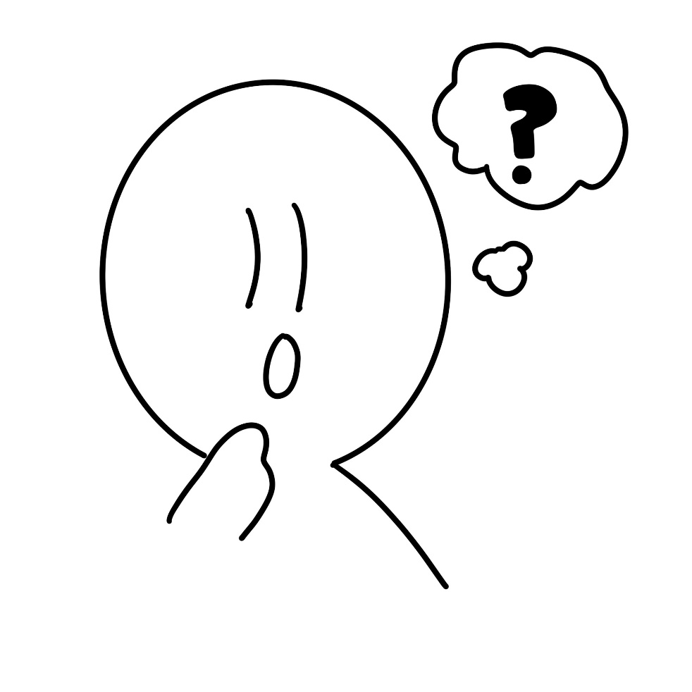
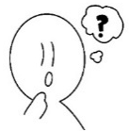
Points

