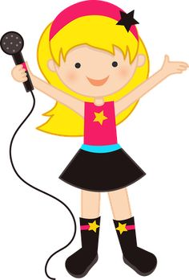
ROUND ONE
Name: _______________ Class: ______ Number: ___
Why do you like this singer?
Because her songs are nice.
Because her voice is beautiful.

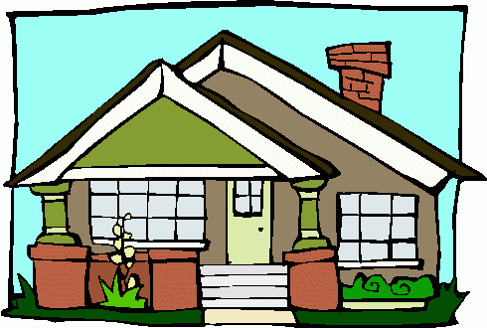
ROUND TWO
Why do you like this house?
Because it has many __________.
Because it has a nice _________.

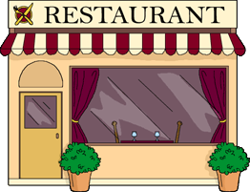
ROUND THREE
Why is this restaurant good?
Because I like the __________.
Because I like the _________.

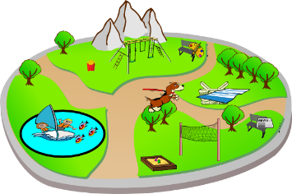
ROUND FOUR
Why is this park good?
Because it is __________.
Because it is _________.

Because she always helps him.
Because it is delicious.
Because they are great dancers.
Because nature is beautiful.
Because she practices every day.
Because he is a nice boy.
Because her voice is beautiful.
Because she likes chocolate.
Because they have many great players.
Because it is an exciting sport.

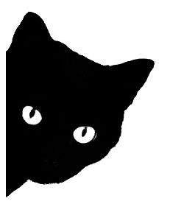
- Why does ____ like _______?
_________________________________________________
__________________________________________ (+1 point)
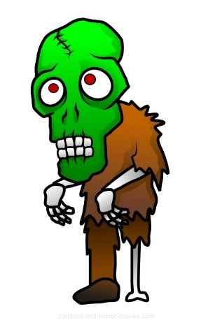
- Why does ____ like _______?
_________________________________________________
__________________________________________ (+1 point)
- Why does ______ like __________?
_________________________________________________
__________________________________________ (+1 point)
- Why does _______ play __________?
_________________________________________________
__________________________________________ (+1 point)
- Why are the _______ __________?
_________________________________________________
__________________________________________ (+1 point)
- Why is ____ a good _______ ________?
_________________________________________________
__________________________________________ (+1 point)
- Why does ________ like ___________?
_________________________________________________
__________________________________________ (+1 point)
- Why does ____________ love _____________?
___________________________________________
_____________________________________(+1 point)
- What is your favorite food?
Name: _______________ Class: ______ Number: ___
____________________________________________________
Why do you like it?
____________________________________________________
- What do you play?
____________________________________________________
Why do you play it?
____________________________________________________
- Who is your favorite famous person?
____________________________________________________
Why do you like him/her?
____________________________________________________
- What is your favorite place?
____________________________________________________
Why do you like it?
____________________________________________________
- What is your favorite TV program?
____________________________________________________
Why do you watch it?
____________________________________________________
BONUS QUESTIONS
- What is your favorite sport?
- Where do you buy milk?
- What time did you get up today?
- What games can you play?
- What is the teacher doing now?
- What food do monkeys like?
- What food does Doraemon like?
- What time did you go to bed last night?
- What did you eat for breakfast?
- What can a fish do?
- What can a bird do?
- What did you study last night?
- Who is your favorite singer?
- When is your birthday?
- How are you?
- Where do you live?
- What can you cook?
- What can you do in America?
- What did you eat for dinner?

