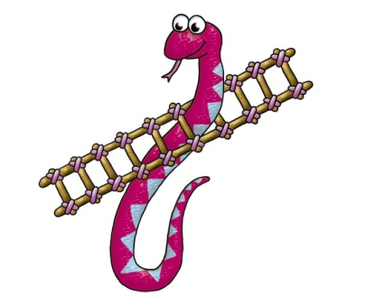
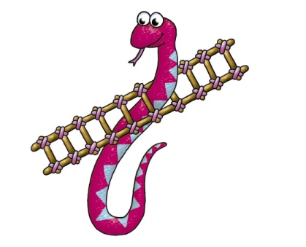
85 | 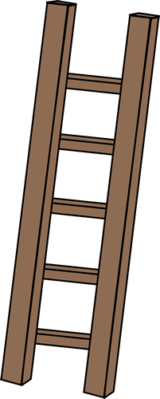  86 | 87 | 88  REVERSE | 89 | 90  GOAL!
84 | 83 | 82  REVERSE | 81 | 80 | 79  REVERSE
73 | 74 | 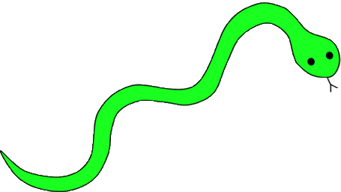  75  What animal do you like?  one more time! | 76 | 77 | 78  What time is it?  one more time!
72 | 71 | 70 | 69  How are you?  one more time! | 68 | 67
61  REVERSE | 62 | 63 | 64 | 65 | 66  How is the weather?  one more time!
60 | 59 | 58  Do you like natto?  one more time! | 57 | 56 | 55
49 | 50  What character do you like?  two more times! | 51  REVERSE | 52 | 53 | 54  REVERSE
48 | 47  REVERSE | 46  What time is it?  one more time! | 45 | 44 | 43
37 | 38 | 39  REVERSE | 40 | 41 | 42  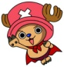  two more times!
36 | 35  What food do you like?  one more time! | 34 | 33 | 32 | 31  How are you?  one more time!
25 | 26  two more times! | 27 | 28  REVERSE | 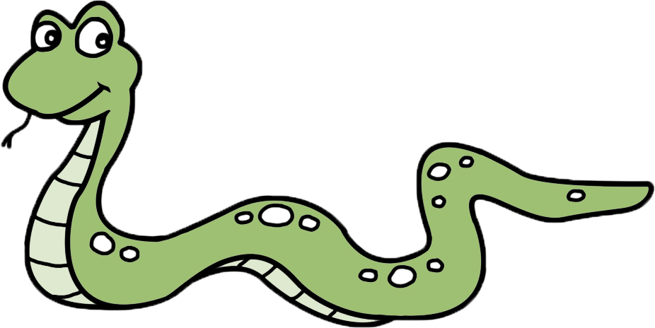  29 | 30
24 | 23 | 22 | 21 | 20 | 19
13 | 14 | 15  REVERSE | 16  What’s the date?  one more time! | 17 | 18
12 | 11  Are you from Japan?  one more time! | 10 | 9 | 8  What day is it?  one more time! | 7
1  START | 2  one more time! | 3 | 4 | 5 | 6

