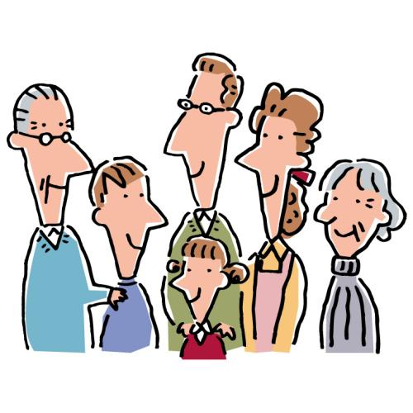
In my house…

Me too!
_________________ is cleaned by ________________________.
Dinner is cooked by ________________________________.
_______________________ is used by _____________________.
________________________________ is spoken.
Our Nengajo are written by ______________________________________.
