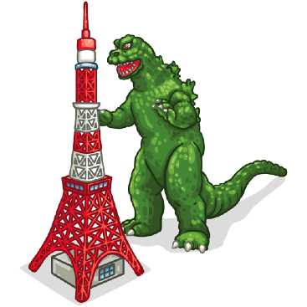
Pronunciation Tree
froze

road load

arrive alive arrive alive

crime climb crime climb crime climb crime climb

lock rock lock rock lock rock lock rock
1 2 3 4 5 6 7 8

lock rock lock rock lock rock lock rock
17 18 19 20 21 22 23 24
flows

load road

alive arrive alive arrive

climb crime climb crime climb crime climb crime

rock lock rock lock rock lock rock lock
9 10 11 12 13 14 15 16

rock lock rock lock rock lock rock lock
25 26 27 28 29 30 32 33
- right/light
- red/led
- road/load
- arrive/alive
- correct/collect
- crime/climb
- bread/bled
- froze/flows
- rock/lock
arrive

