If (First Conditional)

Please choose the correct words and write them down.

1. If you study hard,

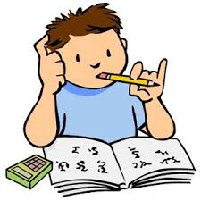
you _________________ the exam.

passed
pass
will pass

2. I will go the party if ___________________ time.
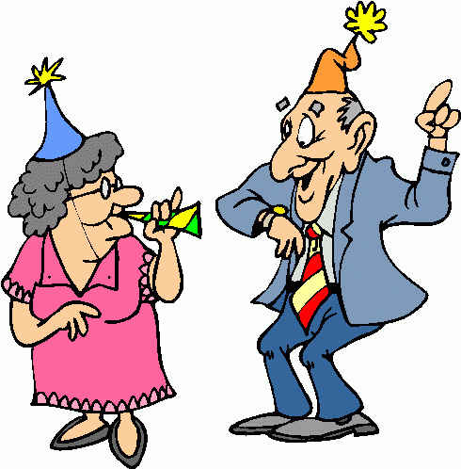
I had
I will have
I have

3. If we _____________________ the game,
we _______________________.

win/will celebrate
will win/celebrate
win/will win

4. What _______________________ if it rains?
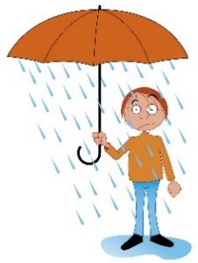
will you do
did you do
do you do

5. If the weather ________________ good,
I _________________ tennis.

was/played
is/will play
will be/will play

6. If I _________________ to the supermarket,

I _________________ some strawberry jam.

will go/will buy
went/would buy
go/will buy

7. If I ___________________,

I _____________________ the exam.

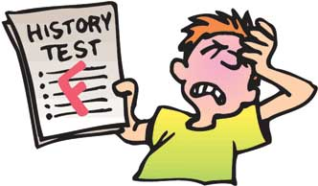
study/won’t pass
don’t study/won’t pass
studied/won’t pass

8. What _________________

if you _________________ to the cinema?
will you watch/will go
will you watch/go
do you watch/go

9. I ___________________ a blue dress

if I ___________________ to the party.
will wear/came
will wear/come
wear/come

10. I ____________ home if it ___________ tomorrow.
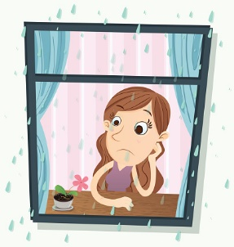
will stay/rains
stay/will rain
will stay/rain

