Name ______________________ Class _____ Number _____
He is my classmate.

Examples:
. This is Jill.
She is my classmate.
. She is from Oizumigakuen.
. She is 12 years old.

. This is Alex.
He is my classmate.
. He is from Takamatsu.
. He is 12 years old.

A: Ask a boy and a girl these questions:
Questions: (質問) Answers: (回答)

. What is your name? . My name is …………………………..
. Where are you from? . I’m from ……………………………….
. How old are you? . I’m ………… years old.

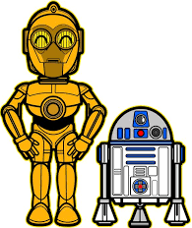
B: Write down their answers:
For example: “He is from Takamatsu.”
Boy:
. ______________________________________________________________________________________
__________ is my classmate.
. ______________________________________________________________________________________
. ______________________________________________________________________________________
__________________________________________

Girl:
. ______________________________________________________________________________________
__________ is my classmate.
. ______________________________________________________________________________________
. ______________________________________________________________________________________
__________________________________________

