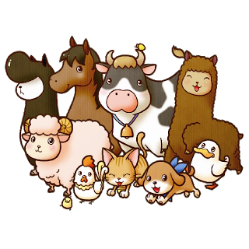
Animal quiz!

Animal:  ______________ | - __________________________________  - __________________________________  - __________________________________

That’s right! | Sorry…
__________ __________ __________  __________ __________ __________  __________ __________ __________  __________ __________ __________ | __________ __________ __________  __________ __________ __________  __________ __________ __________  __________ __________ __________

Animal:  ______________ | - __________________________________  - __________________________________  - __________________________________

That’s right! | Sorry…
__________ __________ __________  __________ __________ __________  __________ __________ __________  __________ __________ __________ | __________ __________ __________  __________ __________ __________  __________ __________ __________  __________ __________ __________

