Do you know him? Do you know her?

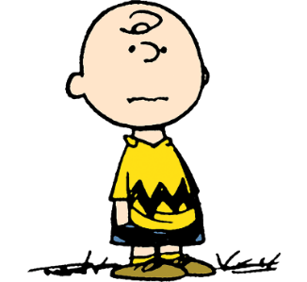  ________________  ________________ | 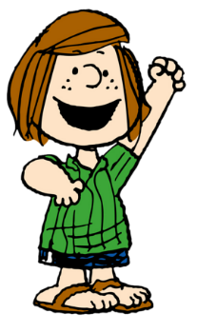  ________________  ________________ | 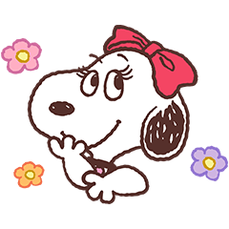  ________________  ________________ | ________________  ________________ | 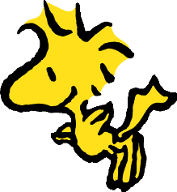  ________________  ________________
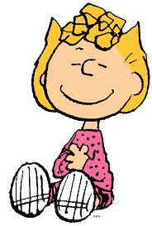  ________________  ________________ | 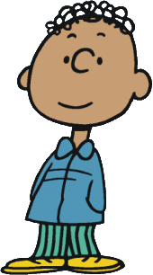  ________________  ________________ | ________________  ________________ | 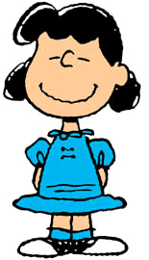  ________________  ________________ | 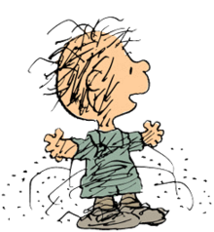  ________________  ________________

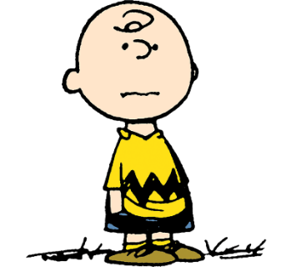  Charlie Brown  チャーリー・ブラウン  He’s Sally’s brother. | 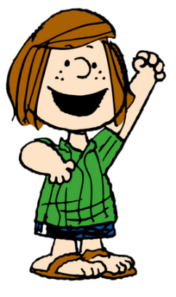  Peppermint Patty  ペパーミント・パティ  She loves Charlie Brown. | Belle  ベル  She’s Snoopy’s sister. | Linus  ライナス  He’s Lucy’s brother. | 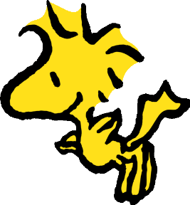  Woodstock  ウッドストック  He’s Snoopy’s  best friend.
Sally  サリー  She’s Charlie’s sister. | Franklin  フランクリン  He’s Charlie Brown’s friend. | Snoopy  He’s Belle’s brother. | Lucy  ルーシー  She’s Linus’ sister. | Pigpen  ピッグペン  His name means “豚小屋” in Japanese.

