Corrections!

1)

|  |  |
| --- | --- |
|  | / |
|  |  |

2)

|  |  |
| --- | --- |
|  | / |
|  |  |

3)

|  |  |
| --- | --- |
|  | / |
|  |  |

4)

|  |  |
| --- | --- |
|  | / |
|  |  |

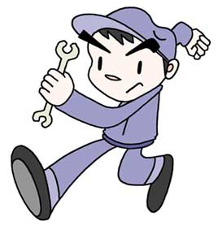

Corrections!

1)

|  |  |
| --- | --- |
|  | / |
|  |  |

2)

|  |  |
| --- | --- |
|  | / |
|  |  |



Corrections!

1)

|  |  |
| --- | --- |
|  | / |
|  |  |

2)

|  |  |
| --- | --- |
|  | / |
|  |  |

Corrections!

3)

|  |  |
| --- | --- |
|  | / |
|  |  |

4)

|  |  |
| --- | --- |
|  | / |
|  |  |



Corrections!

3)

|  |  |
| --- | --- |
|  | / |
|  |  |

4)

|  |  |
| --- | --- |
|  | / |
|  |  |