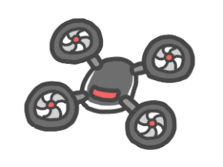
What rules should we have for using drones?

What are some good things and bad things about drones? What do you think?
Bad things

Good things

Do you think it’s okay to use drones?

Anyone can use them any time | Pilots need to have a license | Only police and firefighters can use them | Nobody should use them

Why?

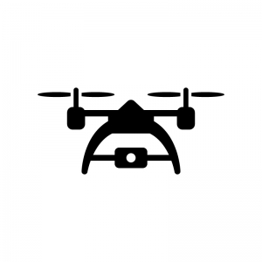

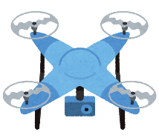
Drones

Maybe you’ve heard about drones. They’re small flying crafts that don’t need a pilot. In the last 10 years they have become much cheaper, and normal people can buy them. People can use drones to take amazing videos and photos from the sky. They can be used in an emergency to go to places that humans can’t reach. Amazon is considering using drones to deliver packages. Some people even race them!
Unfortunately, drones also create some problems. Drones can be used to carry harmful things like guns or bombs. When they’re used near houses, the noise can disturb people and the drone owner can look inside windows. It’s very dangerous to use drones near helicopters or planes, since they could crash if the drone hit them. If a drone falls into a group of people, some of them could be injured.
Many countries have started making laws for drones. In Japan, people can’t fly drones in areas with houses or near airports. Drones have to fly below 150 meters, and can’t go closer than 30 meters from people or buildings. In the USA, you must have a license to fly a drone.
What do you think about drones?

Vocabulary
crafts |  | disturb | 迷惑をかける
amazing | すごい、すばらしい | look inside | を覗く
can’t reach | 手が届けない | crash | 墜落
consider | 考える | injure | けがをする
deliver packages | 荷物を届く | law | 法律
harmful | 有害 | license | 免許

